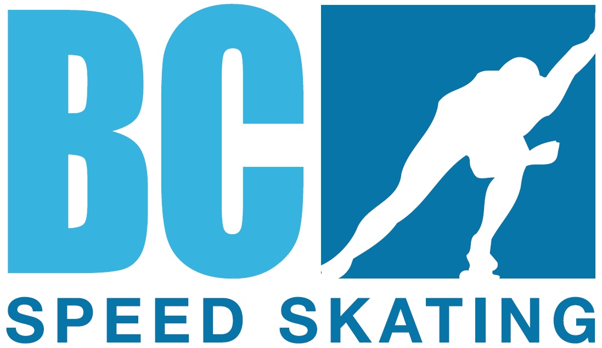

British Columbia Speed Skating Association

Strategic Plan

2015 – 2019

rev.11.04.2015:
**** Table of Contents****
Vision and Mission Statement:…... …………………………………………………………………………………………………………………………………....4
Core Values: 5
1. Governance 7
2. Finance 7
3. Marketing 7
4. Communications
Increased Opportunities 7
5. Public and Private Partnerships
6. Club & Community Membership Development 7
7. Membership Services 7
An Integrated Sports Model 7
8. Public and Private Partnerships………………………………………………………………………………………………………………………………………….
9. Athlete Development 7
10. Regional and Grassroots Development 7
Technical and Enhanced Development 7
11. Coaches 7
12. Officials 7
Summary of Objectives 8
1. Governance/ Planning 8
2. Finance 8
3. Marketing 8
4. Club & Community Development 8
5. Membership Services 8
6. Athlete Development 8
7. Regional and Grass Roots Development 9
8 Coaches 8
9. Officials…………………………………………………………………………………………………………………………………………………………………...9
Strategies to Accomplish Our Principal Focus 11
1. Governance/ Planning 10
2. Finance 11
3. Marketing 10
4. Club & Community Development 11
5. Membership Services 10
6.. Athlete Development 11
7. Regional and Grass Roots 11
8.. Coaches: 111
9. Officials: 12

Additional plan information:

We have implemented Speed Skating Canada’s Long Term Participation and Athletes Development Model (LTPAD) across all technical sectors.

- British Columbia Speed Skating Athletes Development Model
- British Columbia Speed Skating Sports System Model
- British Columbia Speed Skating Officials Development Model
- British Columbia Speed Skating Coaches Development Model

Vision Statement:
To foster the growth and development of Speed Skating in British Columbia by providing quality services and support programs to all members in their pursuit of a healthy lifestyle while encouraging challenges and promoting excellence.

Mission Statement:
The British Columbia Speed Skating Association is committed to presenting speed skating as a lifetime sport, with opportunities for participation; outstanding service and leadership within the sport community. We will be viewed as an equal, dynamic, innovative and pro-active sport within the Province and across Canada.

Core Values:

- We believe each member is an integral part of our association.
- We actively support controlled shared governance, which includes the responsibility and ownership of accountabilities and outcomes.
- We recognize our duty to maximize each member’s potential for growth and development.
- We believe in athlete centeredness, as it pro actively shapes an environment to promote excellence at all levels.
- We recognize our responsibility to provide a safe environment for our athletes and membership.
- We believe the use of drugs to enhance performance in training and competition is harmful to health, ethically wrong and a threat to sport.
- We believe that athlete, coaching, officials and administrative development are equal partners in sport. It is the Association’s strong commitment to each that will provide positive, balanced growth.
- We believe all members of the organization; staff, athletes, coaches, officials, administrators, parents and volunteers are entitled to be treated in an ethical and professional manner.
- We believe that recognition is a cornerstone of all volunteer organizations and as such is an integral part of all Association programs.

Mission

The British Columbia Speed Skating Association is committed to present speed skating as a life time sport, with opportunities for participation; outstanding service and leadership within the sport community. We will be viewed as an equal, dynamic, innovative and pro-active sport within the Province and across Canada.

Principal
Focus

Organization

Best Possible Governance and Structure

Principal
Focus

Coaching & Official Development
Highest Level and enhanced numbers

Principal
Focus

Athlete Development

Excellence and Achievement

Principal
Focus

Membership Development

Increase participation and awareness at all levels

Best Possible Structure and Governance

Athlete Development

Coaching and Officials Development

Membership Development

Attained by Attained by Attained by Attained by
An effective approach to  - Governance  - Finance  - Marketing  - Communications | Increased Opportunities  - Public & Private partnerships  - Club & Community Membership Development  - Membership Services | An Integrated Sports Model  - Public & Private partnerships  - Athlete Development  - Regional and Grass Roots Development | Technical and Enhanced Development  - Coaches  - Officials

Summary of Objectives

1. Governance/ Planning  - Annually Review and evaluate Strategic Plan  - Review and maintain operational governance consistent with the By-Laws and the Policies of the Association  - Ensure the continual growth, development and sustainability of speed skating in British Columbia  2. Finance  - Ensure financial stability sufficient to meet the goals and objectives of the Association.  7. Regional & Grass Roots Development  - To provide holistic opportunities to be the best they can be.  * Provide opportunities to engage:  -those with disabilities and special needs  -Mentally challenged  -Minorities  8. Coaches  - Provide professional and volunteer coaches to support athlete development  - Increase the NCCP certification level of club coaches  - Increase the number of Volunteer coaches  - Provide access to coaching clinics for past and present skaters  - Provide mentor opportunities for/to club coaches  1. Governance & Planning  - Review Strategic Plan annually  - Assess Yearly Work Plan  - Bi-Annual Review of By-Laws / Procedures and Regulations  - Annual review of Policy Changes of the Association for ratification at the AGM  - Direct association staff to ensure compliance with operational policies.  - Annual accountability to the Membership through:  - Financial Statements  - Budgets  - President and Technical. Chair reports  - Semi-annual planning meetings  - Active participant in planning with partner organizations. | 3. Marketing  - Enhance the visibility of the sport through short and long-term partnership programs and opportunities  - Promote strong public relations with media highlighting the progress & achievements of skaters & volunteers  - Develop team building, promotion & interaction with high performance skaters  - Assist clubs with enhancing relations with local media outlets  4. Club & Community Membership Development  - Develop strategies to maintain and increase the participation of British Columbians in the sport of Speed Skating  - Produce Promotional Material  .  Coaches con’y  - Provide “Intro to Coaching” workshop to new parents  - Provide educational opportunities for coaches in all regions of BC  - Provide improved tracking of coaches  - Enhance recognition program  - Provide opportunities to attend National/Provincial seminars, etc  - Provide professional upgrading opportunities  - Provide opportunities for representation on Prov. & National committees  - Provide resources sufficient to meet stated goals.  2. Finance  - Annually review financial policies.  - Aggressively implement partnerships with funding agencies.  - Partner with supporters / sponsors provincially and at club level  - Manage finances and report monthly to the Board  - Monitor technical committee budgets as required | - Membership Services  - Maintain and enhance existing services and identify future needs  - Develop a on-line club Questionnaire to provide BCSSA common member club needs.  - Assist new clubs in obtaining new equipment  - Enhance communications through PSO website  - Share best practices within each geographic region  - Develop, implement and promote Provincial programs  - Promote and implement NSO programs  - Annually produce “how to” bulletin, distributed to the clubs, to encourage new members  - Officials  - Provide qualified officials to meet Provincial and National requirements for competitions  - Advocate for senior officials to be appointed to National & International events  - Appoint senior officials to high level events in BC  - Advocate for mentorship opportunities at National events  - Provide mentorship opportunities within BC  - Provide improved Official tracking through Provincial data base  3. Marketing  - Develop and sound and strategic marketing and communications plan for provincial and regional partners  - Seek new private funding opportunities  - Connect and develop partnerships with corporate - private sponsors  - Increase visibility through media outlets  - Develop media and print relationships and advertising  - Appoint media liaison for member clubs  - Aggressively promote and sell BCSSA properties.  - Pool resources when reporting to media | 6. Athlete Development  - Increase number of BC athletes on national teams in both disciplines  - Increase number of BC athletes on national development teams in both disciplines  - Increase medal count at National and Regional events  - Increase medal count at CWG  - Increase top 10 placements at National and Regional events  - Expand development (talent pool) team based on pre-set criteria  Officials con’t  - Provide “Intro to Officiating” clinics targeting present and former speed skaters  - Provide mentoring opportunities for club officials  - Ensure educational opportunities for officials in all regions of BC  - Provide opportunities for qualified BC officials to attend NSO seminars / workshops  4. Club & Community Membership Development  - Create partnership opportunities with 1st Nations communities  - Partner with service groups  - Partner with school boards to implement the “NSO” learn to skate program  - Partner with community “Learn to Skate” programs  - Be included in community / recreation sport calendars

Strategies to Accomplish Our Principal Focus
5. Membership Services  - Create 1 page promotional poster for use by clubs promoting speed skating as a Sport for Life  - Create 1 page print media insert with “tag” line for local clubs  - Create 1 page community centres poster promoting our sport with local “tag” line.  - Create “pocket” folder for clubs to distribute.  - Athlete Development  - Hire Performance Coach  - Create structured “Development” (formerly talent pool) program  - Create progressive competition formats to support development program  - Increase visibility of Performance Skaters through media outlets  - Recognize Performance stream skaters  - Work with City of FSJ to maximize Provincial use of covered oval  8 Coaches  - Partner with CSI / Pacific Sport to provide access to technical clinics and seminars  - Identify scheduled clinics on Provincial Events calendar on web site  - Create and implement Junior Coaching program  - In partnership with the Ministry of Education promote the External Course Credits program  - Designate coaches to targeted national competitions  - Provide technical coaching clinics  - Provide access to NCCP programs  - Increase the number of certified “Intro to Comp” coaches  - Provide improved tracking of coaches through Prov. Database  - Provide coach mentor program | Athlete Development con’t  - Partner with CSI to implement regional training center’s  - Access funding to provide Performance skaters with sport science support  - Re-align competition schedule and format to reflect NSO LTPAD  - Create regional training camps to allow easier travel access  - Provide support to allow targeted skaters access to Regional and National Training Center’s and coaches  - Provide improved tracking of skaters results through Provincial Data base  - Partner with NSO to provide meaningful competitions  - Provide opportunities to high performance competitions  - Revise ranking systems  - Provide resources sufficient to meet stated goals  Coaches con’t  - Enhance recognition Program  - Facilitate invitations to attend Provincial & National workshops, seminars, clinics, and symposia  - Establish and maintain a resource library which coaches can access electronically  - Facilitate professional upgrading opportunities  - Encourage representation on Provincial and National Coaching Committees  - Provide resources sufficient to meet stated goals. | - Regional & Grass Roots  - Provide access to progressive priority development programs.  - Develop Provincial Development Training Centre’s.  - Provide introduction to sport sciences programs.  - Provide developmentally appropriate camps and events  - Enhance recognition programs including Awards / Badge/Pin Programs  - Provide meaningful and appropriate competitive opportunities for all levels.  - Provide support to developmental and performance competitions.  - Personal best program.  - Support the clubs by:  - Increasing their membership by a minimum of 10% per year  - Promote speed skating within their communities  - Help promote events at malls, parks, demos and trade-fairs  9. Officials  - Provide access to technical clinics and seminars  - Identify and publish scheduled clinics on Provincial calendar  - Provide access to NSO Officials Development and certification program  - Provide officiating opportunities at Provincial / Regional and National competitions  - Annual review of the evaluation program  - Annual review of the Junior Officials program  - Encourage participation in Junior Officials Program  - In partnership with the Ministry of Education promote the External Course credits program  - Create and implement Officials mentor program  - Access community volunteer databases to encourage officiating in our sport.  - Provide tools to clubs to assist in promoting officiating | Regional & Grass Roots con’t  - Provide club-kit for community promotions  - Provide a process to help attract 1st nations communities into our sport  - Promote CS4L within Masters age groups  - Engage and share activities with  ringette / hockey / figure skating  - Provide workshops to clubs on best practices to increase membership  - Implement recognition program for club membership growth  - Support clubs in obtaining new equipment  - Provide resources sufficient to meet stated goals  Officials con’t  - Provide annual officials bulletin  - Partner with NSO to bring in senior NSO officials to mentor developing club officials  - Encourage clubs to designate officials liaison  - Encourage participation in upgrading certification process  - Encourage and support participation on NSO committees  - Provide resources sufficient to meet stated goals.

